**Deep Dive into RLHF**

**Introduction**

In this lesson, we will dive deeper into Reinforcement Learning from Human Feedback (RLHF), a method that combines human feedback and reinforcement learning to enhance the alignment and efficiency of Large Language Models.

We explore the RLHF training process, compare it with Supervised Fine-Tuning (SFT), and discuss its alternatives, such as **Direct Preference Optimization (DPO)** and **Reinforced Self-Training (ReST**).

By the end of this lesson, you'll have a comprehensive understanding of how RLHF and its alternatives are used to improve the performance and safety of LLMs.

**Understanding RLHF**

[Reinforcement Learning from Human Feedback (RLHF)](https://arxiv.org/abs/1909.08593) is a method that integrates human feedback and reinforcement learning into LLMs, enhancing their alignment with human objectives and improving their efficiency.

RLHF has shown significant promise in making LLMs safer and more helpful. It was used for the first time for creating [InstructGPT](https://openai.com/research/instruction-following), a finetuned version of GPT3 for following instructions, and it’s used nowadays in the last OpenAI models ChatGPT (GPT-3.5-turbo) and GPT-4.

RLHF leverages **human-curated rankings** that act as a signal to the model, directing it to favor specific outputs over others, thereby encouraging the production of more reliable, secure responses that align with human expectations. All of this is done with the help of a reinforcement learning algorithm, namely [**PPO**](https://openai.com/research/openai-baselines-ppo)**, that optimizes the underlying LLM model,** leveraging the human-curated rankings.

**RLHF Training Process**

RLHF can be useful in guiding LLMs to generate appropriate texts by treating **text generation as a reinforcement learning problem**. In this approach, the **language model serves as the RL agent**, the possible **language outputs represent the action space**, and the **reward** is based on how well the LLM's response aligns with the context of the application and the user's intent.

RLHF must be done on an already pretrained LLM. A language model must be trained in advance on a large corpus of text data collected from the internet.

The RLHF training process can then be broken down into the following steps.

* **(Optional) Finetune the LLM by following instructions**: This is an optional step, but some sources recommend fine-tuning raw LLM in advance by following instructions, using a specialized dataset for it. This step should make the following RL finetuning of RLHF converge faster.
* **RLHF dataset creation**: The LLM is used to generate a lot of text completions from a set of instructions. For each instruction, we **collect multiple completions** from the model.
* **Collecting human feedback**: Human labelers then rank the generated completions to the same instruction from best to worst. Humans can be asked to **rank the completions**, keeping into account several aspects, such as **completeness, relevancy, accuracy, toxicity, bias**, etc. It’s possible to convert these ranks into scores that we can assign to the text completions in our dataset, where a high score means that the completion is good.
* **Training a Reward Model**: The RLHF dataset is used to train a reward model, which means a model that, when provided with an instruction and a text completion, assigns a score to the completion. In this context, a high score indicates that the completion is good. The reward model does a very similar job to what human labelers did on the dataset. The reward model is expected to learn, from the RLHF dataset, **how to assign scores** according to all the aspects taken into account during the labeling process (completeness, relevancy, accuracy, toxicity, bias, etc.)
* **Fine-tuning the Language Model with Reinforcement Learning and the Reward Model**: Starting from a random instruction, our pretrained LLM generates multiple completions. These completions are then assigned scores by the reward model, and these scores are utilized by a reinforcement learning algorithm **(PPO)** to **update the parameters of the LLM**. This process aims to make the LLM more likely to produce completions with higher scores. To prevent the LLM from forgetting helpful information during fine-tuning, the RLHF fine-tuning process also aims to maintain a **small Kullback-Leibler (KL) divergence** between the fine-tuned LLM and the original LLM. This ensures that the token distribution predicted by it remains relatively consistent. After repeating this process for several iterations, we will have our final, finalized LLM.

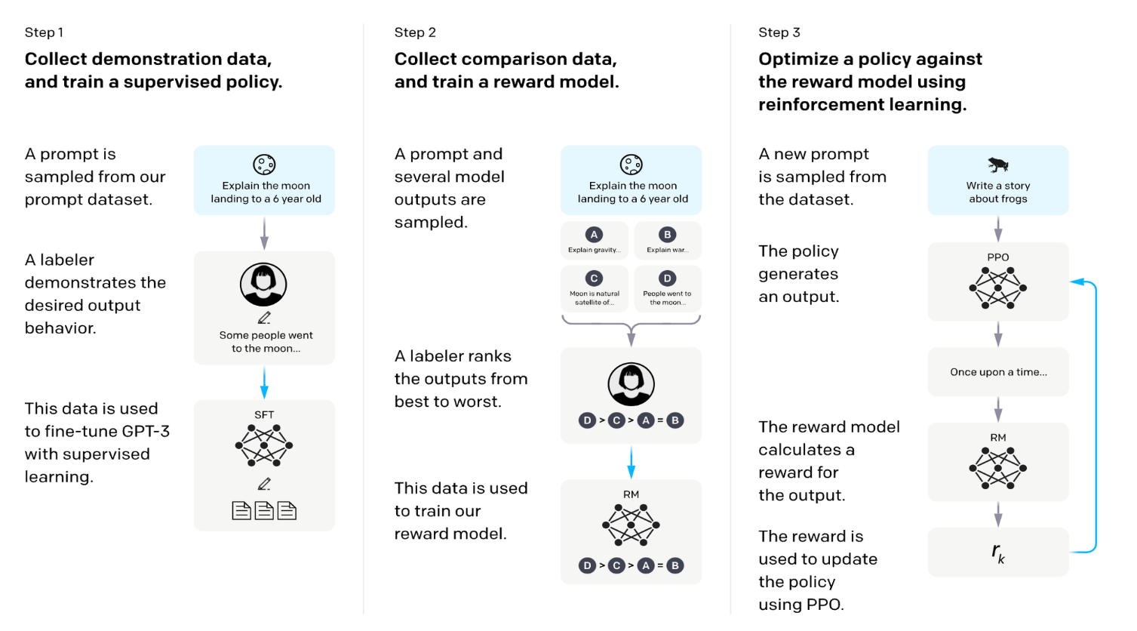

**RLHF vs SFT**

As seen in the previous lessons, aligning LLM to follow instructions with human values is possible by doing simple SFT (with or without LoRA) with a high-quality dataset ([see the LIMA paper](https://arxiv.org/abs/2305.11206)). So, what’s the tradeoff between RLHF and SFT?

In reality, it's still an open question. Empirically, it seems that RLHF **can better teach** the "human alignment" aspects of its dataset if it's sufficiently large and of high quality. However, in contrast, it's **more expensive and time-consuming**. Reinforcement learning, in this context, is still quite unstable, meaning that the results are very sensitive to the initial model parameters and training hyperparameters. It often **falls into local optima**, and the **loss diverges multiple times**, necessitating multiple restarts. This makes it **less straightforward than plain SFT with LoRA.**

**Alternatives to RLHF**

Over time, several alternatives to RLFH have been researched. Here are the most popular of them.

**Direct Preference Optimization**

[Direct Preference Optimization (DPO)](https://arxiv.org/pdf/2305.18290.pdf) is a novel method for finetuning LLMs as an alternative to RLHF.

Unlike RLHF, which requires complex reward functions and careful balance to ensure sensible text generation, DPO simplifies the process by **directly optimizing the language model** using a **binary cross-entropy loss**. It bypasses the need for a reward model and RL-based optimization. Instead, it directly optimizes the language model on preference data. This is accomplished through an analytical mapping from the reward function to the optimal RL policy. It involves directly transforming the RL loss, which typically involves the reward and reference models, into a loss over the reference model.

As a result, DPO potentially simplifies the fine-tuning process of LLMs by eliminating the need for complex RL techniques or a reward model.

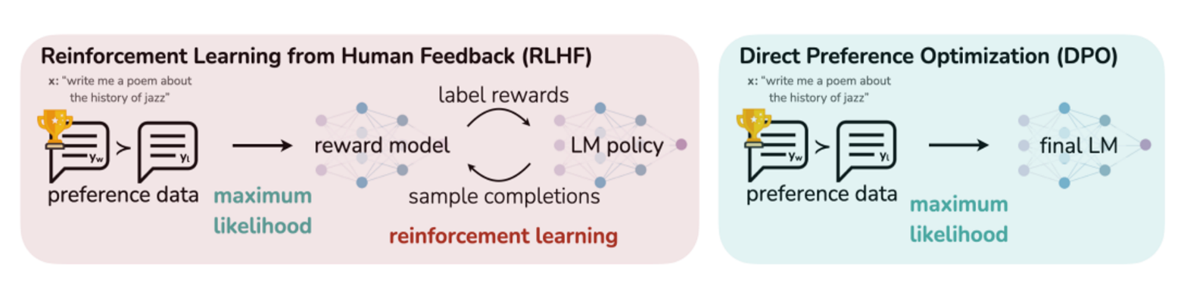

**Reinforced Self-Training**

[Google DeepMind's Reinforced Self-Training (ReST)](https://arxiv.org/pdf/2308.08998.pdf) is a more cost-effective alternative to Reinforcement Learning from Human Feedback. The ReST algorithm operates in a cyclical manner, involving two main steps that are repeated iteratively.

1. The first step, referred to as the 'Grow' step, involves the use of an LLM to generate multiple output predictions for each context. These predictions are then used to augment a training dataset.
2. Following this, the 'Improve' step comes into play. In this phase, the augmented dataset is ranked and filtered using a reward model that has been trained based on human preferences. Subsequently, the LLM is fine-tuned on this filtered dataset using an offline reinforcement learning objective. The fine-tuned LLM is then used in the subsequent Grow step.

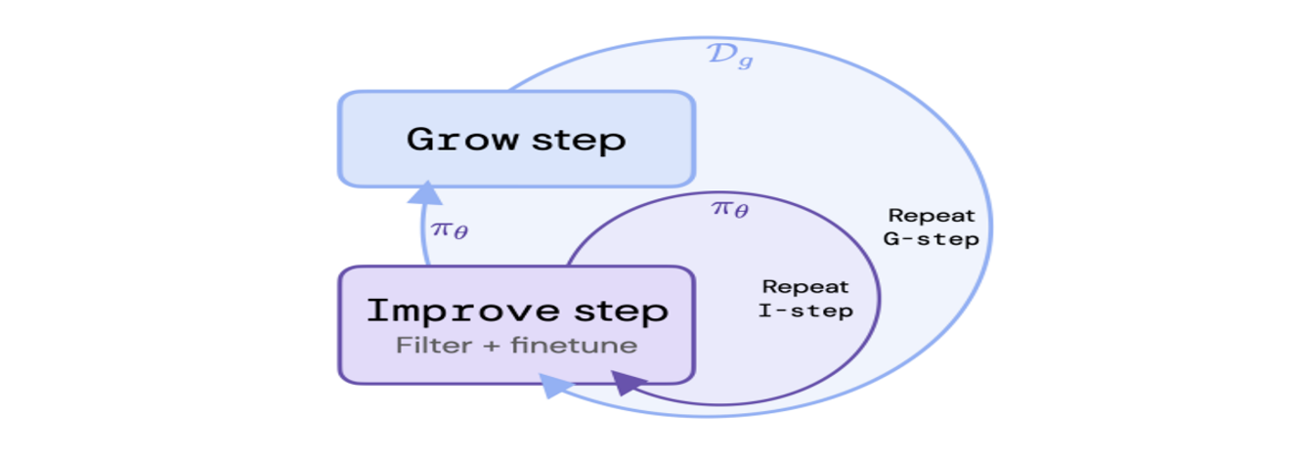

The ReST methodology offers several advantages over RLHF.

* It significantly reduces the computational load compared to online reinforcement learning. This is achieved by leveraging the output of the Grow step across multiple Improve steps.
* The quality of the policy is not limited by the quality of the original dataset, as is the case with offline reinforcement learning. This is because new training data is sampled from an improved policy during the Grow step.
* Decoupling the Grow and Improve steps allows for easy inspection of data quality and potential diagnosis of alignment issues, such as reward hacking.
* The ReST approach is straightforward and stable and only requires tuning a small number of hyperparameters, making it a user-friendly and efficient tool in the machine learning toolkit.

**Reinforcement Learning from AI Feedback (RLAIF)**

Another innovative alternative to RLHF is [Reinforcement Learning from AI Feedback (RLAIF)](https://arxiv.org/abs/2212.08073). Developed by Anthropic, RLAIF aims to address some of the limitations of RLHF, particularly concerning the subjectivity and scalability of human feedback.

In RLAIF, instead of relying on human feedback, an AI Feedback Model is used to provide feedback for training the AI assistant. This Feedback Model is guided by a constitution provided by humans, outlining the essential principles for the model's judgment. This approach allows for a more objective and scalable supervision technique, as it is not dependent on a small pool of human preferences.

The RLAIF process begins with the creation of a dataset of ranked preferences generated automatically by the AI Feedback Model. This dataset is then used to train a Reward Model similar to RLHF. The Reward Model serves as the reward signal in a reinforcement learning schema for an LLM.

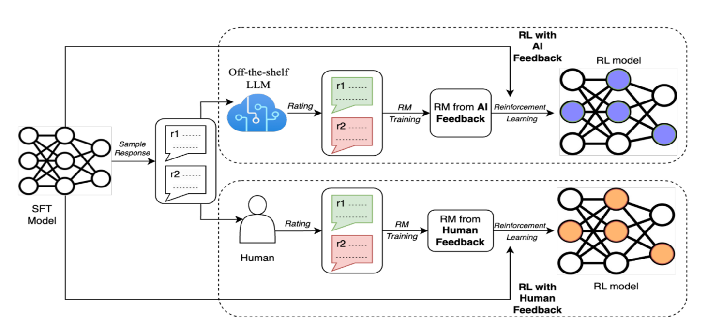

RLAIF offers several advantages over RLHF. **Firstly**, it maintains the helpfulness of RLHF models while making improvements in terms of harmlessness. **Secondly**, it reduces subjectivity as the AI assistant's behavior is not solely dependent on a small pool of humans and their particular preferences. **Lastly**, RLAIF is significantly more scalable as a supervision technique, making it a promising alternative for the future development of safer and more efficient LLMs.

[A recent paper from Google](https://arxiv.org/pdf/2309.00267.pdf) did more experiments with RLAIF and found that humans prefer both RLAIF and RLHF to standard SFT at almost equal rates, indicating that they could be alternatives.

**Conclusion**

This lesson provided a more in-depth exploration of Reinforcement Learning from Human Feedback, a method that combines human feedback and reinforcement learning to enhance the performance and safety of Large Language Models.

We covered the RLHF training process, highlighting its steps and how it leverages human-curated rankings and reinforcement learning to finetune the LLM. We also compared RLHF with Supervised Fine-Tuning (SFT), discussing the trade-offs between the two.

Furthermore, we explored alternatives to RLHF, such as Direct Preference Optimization (DPO) and Reinforced Self-Training (ReST), which offer different approaches to fine-tuning LLMs.

As we continue to refine these techniques, we move closer to our goal of creating LLMs that are more aligned with human values, efficient, and safer to use.

[**https://youtu.be/_66Qp_xZ8Fw**](https://youtu.be/_66Qp_xZ8Fw)

# Improving Trained Models with RLHF

## Introduction

As previously stated, the RLHF process involves incorporating human feedback into the training process **through a reward model** that learns the desired patterns to amplify the model’s output. For instance, if the goal is to enhance politeness, the reward model will guide the model to generate more polite responses by assigning higher scores to polite outputs. This process can be **resource-intensive** due to the need to train an additional reward model using a dataset curated by humans, which can be costly. Nevertheless, we will leverage available open-source models and datasets whenever feasible to explore the technique thoroughly while maintaining acceptable costs.

It is recommended to **begin** the procedure by conducting a **supervised fine-tuning phase**, which enables the model to adjust to a conversational manner. This procedure can be accomplished by using the SFTTrainer class. The **next phase** involves **training a reward model** with the desired traits using the RewardTrainer class in section 2. Finally, the Reinforcement Learning **phase employs the models** from the preceding steps to construct the ultimate aligned model, utilizing the PPOTrainer class in section 3.

After each subsection, the fine-tuned models, the **reports** generated from the **weights and biases**, and the file detailing the requirements for the library can be accessed. Note that different steps might necessitate distinct versions of libraries. We employed the OPT-1.3B model as the foundational model and fine-tuned the DeBERTa (300M) model as the reward model for our experiments. While these are more compact models and might not incorporate the insights of recent larger models like GPT-4 and LLaMA2, the procedure we are exploring in this tutorial can be readily applied to other existing networks by simply modifying the model key name in the code.

We’ll be using a set of 8x100 A100 GPUs in this lesson.

## GPU Cloud - Lambda

In this lesson, we’ll leverage Lambda, Lambda, the GPU cloud designed by ML engineers for training LLMs & Generative AI, for renting GPUs. We can create an account on it, link a billing account, and [rent one instance of the following GPU servers with associated costs](https://lambdalabs.com/service/gpu-cloud/pricing). The cost is for the time your instance is up and not only for the time you’re training your model, so remember to turn the instance off. For this lesson, we rented an 8x NVIDIA A100 instance comprising 40GB of memory at the price of $8.80/h.

⚠️ Beware of costs when you borrow cloud GPUs. The total cost will depend on the machine type and the up time of the instance. Always remember to monitor your costs in the billing section of Lambda Labs and to spin off your instances when you don’t use them.

💡If you just want to replicate the code in the lesson spending very few money, you can just run the training in your instance and stop it after a few iterations.

## Training Monitoring - Weights and Biases

To ensure everything is progressing smoothly, we’ll log the training metrics to Weights & Biases, allowing us to see the metrics in real-time in a suitable dashboard.

## 1. Supervised Fine-Tuning

We thoroughly covered the SFT phase in the previous lessons. If any steps are unclear, refer to the previous lessons.

In this tutorial, the differences are in how we use a distinct dataset called [OpenOrca](https://huggingface.co/datasets/Open-Orca/OpenOrca) and in applying the **QLoRA** method, which we will elaborate on in the subsequent sections.

The OpenOrca dataset comprises 1 million interactions with the language model extracted from the original [OpenOrca](https://huggingface.co/datasets/Open-Orca/OpenOrca) dataset. Each interaction in this collection is comprised of a question paired with a corresponding response. This phase aims to familiarize the model with the conversational structure, thereby teaching it to answer questions rather than relying on its standard auto-completion mechanism.

Begin the process by installing the necessary libraries.

pip install -q transformers==4.32.0 bitsandbytes==0.41.1 accelerate==0.22.0 deeplake==3.6.19 trl==0.5.0 peft==0.5.0 wandb==0.15.8

### 1.1. The Dataset

The initial phase involves streaming the dataset via the Activeloop's performant dataloader to facilitate convenient accessibility. As previously indicated, we employ a subset of the original dataset containing 1 million data points. Nevertheless, the complete dataset (4 million) is accessible at [this URL](https://app.activeloop.ai/genai360/OpenOrca-4M/).

import deeplake

*# Connect to the training and testing datasets*

ds = deeplake.load('hub://genai360/OpenOrca-1M-train-set')

ds_valid = deeplake.load('hub://genai360/OpenOrca-1M-valid-set')

print(ds)

The sample code.

Dataset(path='hub://genai360/OpenOrca-1M-train-set', read_only=True, tensors=['id', 'question', 'response', 'system_prompt'])

The output.

The dataset has three significant columns. These encompass question, also referred to as prompts, which are the queries we have from the LLM: response, i.e., the model's output or answers to the questions, and finally, system_prompt, i.e., the initial directives guiding the model in establishing its context, such as "you are a helpful assistant.”

For simplicity, we exclusively utilize the initial two columns. It could also be beneficial to incorporate the system prompts while formatting the text. This template formats the text in the structure of Question: xxx\n\nAnswer: yyy, where the question-and-answer sections are divided by two newline characters. There's room for experimentation with diverse formats, like trying out System: xxxnnQuestion: yyynnAnswer: zzz, to effectively integrate the system prompts from the dataset.

Copy

def prepare_sample_text(example):

"""Prepare the text from a sample of the dataset."""

text = f"Question: {example['question'][0]}\n\nAnswer: {example['response'][0]}"

return text

Moving forward, the next step is loading the OPT model tokenizer.

from transformers import AutoTokenizer

tokenizer = AutoTokenizer.from_pretrained("facebook/opt-1.3b")

Next, the ConstantLengthDataset class will come into play, serving to aggregate samples to maximize utilization within the 2K input size constraint and enhance the efficiency of the training process.

from trl.trainer import ConstantLengthDataset

train_dataset = ConstantLengthDataset(

tokenizer,

ds,

formatting_func=prepare_sample_text,

infinite=True,

seq_length=2048)

eval_dataset = ConstantLengthDataset(

tokenizer,

ds_valid,

formatting_func=prepare_sample_text,

seq_length=1024)

iterator = iter(train_dataset)

sample = next(iterator)

print(sample)

train_dataset.start_iteration = 0

The sample code.

{'input_ids': tensor([ 16, 358, 828, ..., 137, 79, 362]), 'labels': tensor([ 16, 358, 828, ..., 137, 79, 362])}

The output.

### 1.2. Initialize the Model and Trainer

Finally, we initialize the model and apply LoRA, which effectively keeps memory requirements low when fine-tuning a large language model.

from peft import LoraConfig

lora_config = LoraConfig(

r=16,

lora_alpha=32,

lora_dropout=0.05,

bias="none",

task_type="CAUSAL_LM",

)

The sample code.

Now, we instantiate the TrainingArguments, which define the hyperparameters governing the training loop.

from transformers import TrainingArguments

training_args = TrainingArguments(

output_dir="./OPT-fine_tuned-OpenOrca",

dataloader_drop_last=True,

evaluation_strategy="steps",

save_strategy="steps",

num_train_epochs=2,

eval_steps=2000,

save_steps=2000,

logging_steps=1,

per_device_train_batch_size=8,

per_device_eval_batch_size=8,

learning_rate=1e-4,

lr_scheduler_type="cosine",

warmup_steps=100,

gradient_accumulation_steps=1,

bf16=True,

weight_decay=0.05,

ddp_find_unused_parameters=False,

run_name="OPT-fine_tuned-OpenOrca",

report_to="wandb",

)

Now, we are using the BitsAndBytes library to execute the **quantization** process and load the model in a 4-bit format. We will employ the NF4 data type designed for weights and implement the nested quantization approach, which effectively reduces memory usage with negligible decline in performance. Finally, we indicate that the training process computations should be carried out using the bfloat16 format.

The QLoRA method is a recent approach that combines the LoRA technique with quantization to reduce memory usage. When loading the model, it's necessary to provide the quantization_config.

Copy

import torch

from transformers import BitsAndBytesConfig

quantization_config = BitsAndBytesConfig(

load_in_4bit=True,

bnb_4bit_quant_type="nf4",

bnb_4bit_use_double_quant=True,

bnb_4bit_compute_dtype=torch.bfloat16

)

The sample code.

The following code segment utilizes the AutoModelForCasualLM class to load the pre-trained weights of the OPT model, which holds 1.3 billion parameters. It's important to note that a GPU is required in order to make use of this capability.

from transformers import AutoModelForCausalLM

from accelerate import Accelerator

model = AutoModelForCausalLM.from_pretrained(

"facebook/opt-1.3b",

quantization_config=quantization_config,

device_map={"": Accelerator().process_index}

)

The sample code.

Prior to initializing the trainer object, we introduce modifications to the model architecture for efficiency. This involves casting specific layers of the model to full precision (32 bits), including LayerNorms and the final language modeling head.

from torch import nn

for param in model.parameters():

param.requires_grad = False

if param.ndim == 1:

param.data = param.data.to(torch.float32)

model.gradient_checkpointing_enable()

model.enable_input_require_grads()

class CastOutputToFloat(nn.Sequential):

def forward(self, x): return super().forward(x).to(torch.float32)

model.lm_head = CastOutputToFloat(model.lm_head)

Lastly, The SFTTrainer class will utilize the initialized dataset and model, in combination with the training arguments and LoRA technique, to start the training process.

from trl import SFTTrainer

trainer = SFTTrainer(

model=model,

args=training_args,

train_dataset=train_dataset,

eval_dataset=eval_dataset,

peft_config=lora_config,

packing=True,)

print("Training...")

trainer.train()

The sample code.

The SFTTrainer instance will automatically create checkpoints during the training process, as specified by the save_steps parameter, and store them in the ./OPT-fine_tuned-OpenOrca directory.

We're required to merge the LoRA layers with the base model to form a standalone network, a procedure outlined earlier. The subsequent section of code will handle the merging process.

from transformers import AutoModelForCausalLM

import torch

model = AutoModelForCausalLM.from_pretrained(

"facebook/opt-1.3b", return_dict=True, torch_dtype=torch.bfloat16

)

from peft import PeftModel

*# Load the Lora model*

model = PeftModel.from_pretrained(model, "./OPT-fine_tuned-OpenOrca/<step>")

model.eval()

model = model.merge_and_unload()

model.save_pretrained("./OPT-fine_tuned-OpenOrca/merged")

The standalone model will be accessible on the ./OPT-supervised_fine_tuned/merged directory. This checkpoint will come into play in Section 3.

## 2. Training a Reward Model

The second step is training a reward model, which learns human preferences from labeled samples and guides the LLM during the final step of the RLHF process. This model will be provided with samples of favored behavior compared to not expected or desired behavior. The reward model will learn to imitate human preferences by assigning higher scores to samples that align with those preferences.

The reward models essentially perform a classification task, where they select the superior choice from a pair of sample interactions using input from human feedback. Various network types can be used and trained to function as reward models. Conversations are focused on the idea that the reward model should match the size of the base model in order to possess sufficient knowledge for practical guidance. Nonetheless, smaller models like DeBERTa or RoBERTa proved to be effective. Indeed, with enough resources available, experimenting with larger models is great. Both these models need to be loaded in the next phase of RLHF, which is Reinforcement Learning.

Begin the process by installing the necessary libraries. (We use a different version of the TRL library just in this subsection.)

pip install -q transformers==4.32.0 deeplake==3.6.19 sentencepiece==0.1.99 trl==0.6.0

### 2.1. The Dataset

💡 Please note that the datasets used in this step contain inappropriate language and offensive words. Nevertheless, this approach is the preferred way to align the model's behavior by exposing it to such language and instructing the model not to replicate it.

We will utilize the "[helpfulness/harmless](https://github.com/anthropics/hh-rlhf)" (hh) dataset from Anthropic, specifically curated for the Reinforcement Learning from Human Feedback (RLHF) procedure (you can read more about it [here](https://arxiv.org/abs/2204.05862)). The Activeloop datasets hub provides access to a dataset that allows us to stream the content effortlessly using a single line of code. The subsequent code snippet will establish the data loader object for both the training and validation sets.

import deeplake

ds = deeplake.load('hub://genai360/Anthropic-hh-rlhf-train-set')

ds_valid = deeplake.load('hub://genai360/Anthropic-hh-rlhf-test-set')

print(ds)

Dataset(path='hub://genai360/Anthropic-hh-rlhf-train-set', read_only=True, tensors=['chosen', 'rejected'])

The output.

Moving forward, we need to structure the dataset appropriately for the Trainer class. However, before that, let's load the pretrained tokenizer for the DeBERTa model we will use as the reward model. The code should be recognizable; the AutoTokenizer class will locate the suitable initializer class and utilize the .from_pretrained() method to load the pretrained tokenizer.

from transformers import AutoTokenizer

tokenizer = AutoTokenizer.from_pretrained("microsoft/deberta-v3-base")

As presented in earlier lessons, the Dataset class in PyTorch is in charge of formatting the dataset for various downstream tasks. A pair of inputs is necessary to train a reward model. The first item will denote the chosen (favorable) conversation, while the second will represent a conversation rejected by labelers, which we aim to prevent the model from replicating. The concept revolves around the reward model, which assigns a higher score to the chosen sample while assigning lower rankings to the rejected ones. The code snippet below initially tokenizes the samples and then aggregates the pairs into a single Python dictionary.

from torch.utils.data import Dataset

class MyDataset(Dataset):

def __init__(self, dataset):

self.dataset = dataset

def __len__(self):

return len(self.dataset)

def __getitem__(self, idx):

chosen = self.dataset.chosen[idx].text()

rejected = self.dataset.rejected[idx].text()

tokenized_chosen = tokenizer(chosen, truncation=True, max_length=max_length, padding='max_length')

tokenized_rejected = tokenizer(rejected, truncation=True, max_length=max_length, padding='max_length')

formatted_input = {

"input_ids_chosen": tokenized_chosen["input_ids"],

"attention_mask_chosen": tokenized_chosen["attention_mask"],

"input_ids_rejected": tokenized_rejected["input_ids"],

"attention_mask_rejected": tokenized_rejected["attention_mask"],

}

return formatted_input

The sample code.

The Trainer class anticipates receiving a dictionary containing four keys. This includes the tokenized forms for both chosen and rejected conversations (input_ids_chosen and input_ids_rejected) and their respective attention masks (attention_mask_chosen and attention_mask_rejected). As we employ a padding token to standardize input sizes (up to the model's maximum input size, 512 in this case), it's important to inform the model that certain tokens at the end don't contain meaningful information and can be disregarded. This is why attention masks are important.

We can create a dataset instance using the previously defined class. Additionally, we can extract a single row from the dataset using the iter and next methods to verify the output keys and confirm that everything functions as intended.

train_dataset = MyDataset(ds)

eval_dataset = MyDataset(ds_valid)

*# Print one sample row*

iterator = iter(train_dataset)

one_sample = next(iterator)

print(list(one_sample.keys()))

The sample code.

['input_ids_chosen', 'attention_mask_chosen', 'input_ids_rejected', 'attention_mask_rejected']

The output.

### 2.2. Initialize the Model and Trainer

The next steps are quite straightforward. We begin by loading the pretrained DeBERTa model using AutoModelForSequenceClassification, as our aim is to employ the network for a classification task. Specifying the number of labels (num_labels) as 1 is equally important, as we only require a single score to assess a sequence's quality. This score can indicate whether the content is aligned, receiving a high score, or, if it's unsuitable, receiving a low score.

from transformers import AutoModelForSequenceClassification

model = AutoModelForSequenceClassification.from_pretrained(

"microsoft/deberta-v3-base", num_labels=1)

The sample code.

Then, we can create an instance of TrainingArguments, setting the hyperparameters we intend to utilize. There is flexibility to explore various hyperparameters based on the selection of pre-trained models and available resources. For example, if an Out of Memory (OOM) error is encountered, a smaller batch size might be needed.

.

from transformers import TrainingArguments

training_args = TrainingArguments(

output_dir="DeBERTa-reward-hh_rlhf",

learning_rate=2e-5,

per_device_train_batch_size=24,

per_device_eval_batch_size=24,

num_train_epochs=20,

weight_decay=0.001,

evaluation_strategy="steps",

eval_steps=500,

save_strategy="steps",

save_steps=500,

gradient_accumulation_steps=1,

bf16=True,

logging_strategy="steps",

logging_steps=1,

optim="adamw_hf",

lr_scheduler_type="linear",

ddp_find_unused_parameters=False,

run_name="DeBERTa-reward-hh_rlhf",

report_to="wandb",

)

The sample code.

Finally, the RewardTrainer class from the TRL library will tie everything together and execute the training loop. It's essential to provide the previously defined variables, such as the model, tokenizer, and dataset.

Copy

from trl import RewardTrainer

trainer = RewardTrainer(

model=model,

tokenizer=tokenizer,

args=training_args,

train_dataset=train_dataset,

eval_dataset=eval_dataset,

max_length=max_length)

trainer.train()

The trainer will automatically save the checkpoints, which can be utilized in the next and final steps.

## 3. Reinforcement Learning (RL)

The final step of RLHF! This section will integrate the models we trained earlier. Specifically, we will utilize the previously trained reward model to further align the fine-tuned model with human feedback. In the training loop, a custom prompt will be employed to generate a response from the fine-tuned OPT. The reward model will then assign a score based on how closely the response resembles a hypothetical human-generated output. Within the RL process, mechanisms are also in place to ensure that the model retains its acquired knowledge and doesn't deviate too far from the original model's foundation. We will proceed by introducing the dataset, followed by a more detailed examination of the process in the subsequent subsections.

Begin the process by installing the necessary libraries.

pip install -q transformers==4.32.0 accelerate==0.22.0 peft==0.5.0 trl==0.5.0 bitsandbytes==0.41.1 deeplake==3.6.19 wandb==0.15.8 sentencepiece==0.1.99

### 3.1. The Dataset

Given that the process falls under the realm of unsupervised learning, we have the flexibility to choose the dataset for this step. Since the reward model assesses the output without relying on a label, the learning process does not require a question-answer pair. In this section, we will employ Alpaca's OpenOrca dataset, a subset of the [OpenOrca](https://huggingface.co/datasets/Open-Orca/OpenOrca) dataset.

import deeplake

*# Connect to the training and testing datasets*

ds = deeplake.load('hub://genai360/Alpaca-OrcaChat')

print(ds)

Dataset(path='hub://genai360/Alpaca-OrcaChat', read_only=True, tensors=['input', 'instruction', 'output'])

The output.

The dataset comprises three columns: input, which denotes the user's prompt to the model; instruction, which represents the model's directive; and output, which holds the model's response. We only need to use the input feature for the RL process. Before defining a dataset class for proper formatting, it's necessary to load the pre-trained tokenizer corresponding to the fine-tuned model in the first section.

from transformers import AutoTokenizer

tokenizer = AutoTokenizer.from_pretrained("facebook/opt-1.3b", padding_side='left')

The sample code.

In the subsequent subsection, the trainer requires both the query and its tokenized variant. Thus, the query will remain in text format, whereas the input_ids will represent the token IDs. The dataset class format should be recognizable by now. An important point to highlight is that the query variable acts as a template for crafting user prompts, structured as follows: Question: XXX\n\nAnswer: in alignment with the format employed during the supervised fine-tuning (SFT) step.

from torch.utils.data import Dataset

class MyDataset(Dataset):

def __init__(self, ds):

self.ds = ds

def __len__(self):

return len(self.ds)

def __getitem__(self, idx):

query = "Question: " + self.ds.input[idx].text() + "\n\nAnswer: "

tokenized_question = tokenizer(query, truncation=True, max_length=400, padding='max_length', return_tensors="pt")

formatted_input = {

"query": query,

"input_ids": tokenized_question["input_ids"][0],

}

return formatted_input

*# Define the dataset object*

myTrainingLoader = MyDataset(ds)

Additionally, we must establish a collator function responsible for transforming individual samples from the data loader into data batches. This function will later be passed to the Trainer class.

def collator(data):

return dict((key, [d[key] for d in data]) for key in data[0])

The sample code.

### 3.2. Initialize the SFT Models

In this section, we are required to load two models. To begin, let's initiate the process by loading the fine-tuned model, referred to as OPT-supervised_fine_tuned in section 1, utilizing the configuration provided by the PPOConfig class. The majority of the parameters have been elaborated on in earlier lessons, except adapt_kl_ctrl and init_kl_coef. These arguments will be used to control **the KL divergence penalty** to ensure the model doesn't stray significantly from the pre-trained model. Otherwise, it runs the risk of generating nonsensical sentences.

from trl import PPOConfig

config = PPOConfig(

task_name="OPT-RL-OrcaChat",

steps=10_000,

model_name="./OPT-fine_tuned-OpenOrca/merged",

learning_rate=1.41e-5,

batch_size=32,

mini_batch_size=4,

gradient_accumulation_steps=1,

optimize_cuda_cache=True,

early_stopping=False,

target_kl=0.1,

ppo_epochs=4,

seed=0,

init_kl_coef=0.2,

adap_kl_ctrl=True,

tracker_project_name="GenAI360",

log_with="wandb",)

We also need to use the set_seed() function to set the random state for reproducibility, and the current_device variable will store your current device id and will be used later on the code.

from trl import set_seed

from accelerate import Accelerator

*# set seed before initializing value head for deterministic eval*

set_seed(config.seed)

*# Now let's build the model, the reference model, and the tokenizer.*

current_device = Accelerator().local_process_index

The next three code blocks are used to load the supervised fine-tuned (SFT) model. It starts by setting the details for the LoRA to accelerate the fine-tuning process.

from peft import LoraConfig

lora_config = LoraConfig(

r=16,

lora_alpha=32,

lora_dropout=0.05,

bias="none",

task_type="CAUSAL_LM",)

The sample code.

The LoRA config can then be used alongside the AutoModelForCausalLMwithValueHead class to load the pre-trained weights. We utilize the load_in_8bit argument to load the model, employing a quantization technique that reduces weight precision. This helps conserve memory during model training. This model is intended for utilization within the RL loop.

from trl import AutoModelForCausalLMWithValueHead

model = AutoModelForCausalLMWithValueHead.from_pretrained(

config.model_name,

load_in_8bit=True,

device_map={"": current_device},

peft_config=lora_config,)

The sample code.

### 3.3. Initialize the Reward Models

Utilizing the Huggingface pipeline feature makes loading the Reward model straightforward. We need to define the task we are undertaking. In this case, we selected sentiment-analysis, as our fundamental objective revolves around binary classification. Furthermore, it is essential to indicate the path to the pre-trained reward model from the previous section using the model parameter. Alternatively, it could be possible to utilize a model's name from the HuggingFace Hub if a pre-trained reward model is accessible.

The pipeline will automatically load the appropriate tokenizer, and we can initiate classification by providing any text to the defined object.

from transformers import pipeline

import torch

reward_pipeline = pipeline(

"sentiment-analysis",

model="./DeBERTa-v3-base-reward-hh_rlhf/checkpoint-1000",

tokenizer="./DeBERTa-v3-base-reward-hh_rlhf/checkpoint-1000",

device_map={"": current_device},

model_kwargs={"load_in_8bit": True},

return_token_type_ids=False,)

The sample code.

The reward_pipe variable containing the reward model will be employed within the reinforcement learning (RL) training loop.

### 3.4. PPO Training

The final stage involves employing Proximal Policy Optimization (PPO) to enhance the stability of the training loop. It will restrict alterations to the model by preventing excessively large updates. Empirical findings indicate that introducing minor adjustments accelerates the convergence of the training process, it is one of the intuitions behind the PPO.

Before beginning the actual training loop, certain variables need to be defined for integration within the loop. Initially, we establish the output_length_sampler object, which draws samples from a specified range spanning from a defined minimum to a maximum number. We want the outputs to be in the range of 32 to 128 tokens.

from trl.core import LengthSampler

output_length_sampler = LengthSampler(32, 400) *#(OutputMinLength, OutputMaxLength)*

We need to define two sets of dictionaries that will control the generation process for fine-tuned and reward models. We have the ability to configure arguments that oversee the sampling procedure, truncation, and batch size for each respective network during inference. The code block was concluded by setting the save_freq variable, which determines the interval for checkpoint preservation.

sft_gen_kwargs = {

"top_k": 0.0,

"top_p": 1.0,

"do_sample": True,

"pad_token_id": tokenizer.pad_token_id,

"eos_token_id": 100_000,

}

reward_gen_kwargs = {

"top_k": None,

"function_to_apply": "none",

"batch_size": 16,

"truncation": True,

"max_length": 400

}

save_freq = 50

The sample code.

The final action before the actual training loop involves the instantiation of the PPO trainer object. The PPOTrainer class will take as input an instance of PPOConfig, which we defined earlier, the directory of the fine-tuned model from section 1, and the training dataset.

It's worth noting that we have the option to provide a reference model using the ref_model parameter, which will serve as the guide for the KL divergence penalty. In cases where this parameter is not specified, the trainer will default to using the original pre-trained model as the reference.

from trl import PPOTrainer

ppo_trainer = PPOTrainer(

config,

model,

tokenizer=tokenizer,

dataset=myTrainingLoader,

data_collator=collator

)

The sample code.

Now, we can proceed to the last component, which is the training loop. The process begins with obtaining a single batch of samples and utilizing the input_ids, which are the formatted and tokenized prompts (refer to section 3.1) to generate responses using the fine-tuned model. Subsequently, these responses are decoded and combined with the prompt before being fed to the reward model. This allows the reward model to assess their proximity to a human-generated response by assigning scores.

Finally, the PPO object will adjust the model based on the scores by the reward model.

from tqdm import tqdm

tqdm.pandas()

for step, batch in tqdm(enumerate(ppo_trainer.dataloader)):

if step >= config.total_ppo_epochs:

break

question_tensors = batch["input_ids"]

response_tensors = ppo_trainer.generate(

question_tensors,

return_prompt=False,

length_sampler=output_length_sampler,

**sft_gen_kwargs,

)

batch["response"] = tokenizer.batch_decode(response_tensors, skip_special_tokens=True)

*# Compute reward score*

texts = [q + r for q, r in zip(batch["query"], batch["response"])]

pipe_outputs = reward_pipeline(texts, **reward_gen_kwargs)

rewards = [torch.tensor(output[0]["score"]) for output in pipe_outputs]

*# Run PPO step*

stats = ppo_trainer.step(question_tensors, response_tensors, rewards)

ppo_trainer.log_stats(stats, batch, rewards)

if save_freq and step and step % save_freq == 0:

print("Saving checkpoint.")

ppo_trainer.save_pretrained(f"./OPT-RL-OrcaChat/checkpoint-{step}")

The sample code.

Remember to merge the LoRA adaptors with the base model to ensure that the network can be utilized independently as a standalone model in the future. Simply ensure to modify the directory of the saved checkpoint adaptor according to the results.

from transformers import AutoModelForCausalLM

import torch

model = AutoModelForCausalLM.from_pretrained(

"facebook/opt-1.3b", return_dict=True, torch_dtype=torch.bfloat16)

from peft import PeftModel

*# Load the Lora model*

model = PeftModel.from_pretrained(model, "./OPT-RL-OrcaChat/checkpoint-400/")

model.eval();

model = model.merge_and_unload()

model.save_pretrained("./OPT-RL-OrcaChat/merged")

The sample code.

## QLoRA

Earlier, we employed an argument named load_in_8bit during the loading of the base model. This quantization technique significantly reduces the memory requirement when loading large models. A 32-bit floating-point format was utilized for model training in the early stages of neural network development. This entailed the representation of each weight using 32 bits, requiring 4 bytes for storage per weight.

Researchers developed diverse methods to mitigate this constraint with the growth of models and the escalating memory requirements. This led to the utilization of lower-precision values for the loading model. Employing an 8-bit representation for numbers reduces the storage requirement to a mere 1 byte.

In more recent times, an additional advancement allows for models to be loaded in a 4-bit format, further reducing memory demands. It is possible to use the BitsAndBytes library while loading a pre-trained model, as the following code presents.

from transformers import AutoModelForCausalLM, BitsAndBytesConfig

import torch

model = AutoModelForCausalLM.from_pretrained(

model_name_or_path='/name/or/path/to/your/model',

load_in_4bit=True,

device_map='auto',

torch_dtype=torch.bfloat16,

quantization_config=BitsAndBytesConfig(

load_in_4bit=True,

bnb_4bit_compute_dtype=torch.bfloat16,

bnb_4bit_use_double_quant=True,

bnb_4bit_quant_type='nf4' ),

)

The sample code.

It's crucial to remember that this approach relates exclusively to storing model weights and does not affect the training process. Additionally, there's a constant balance to strike between employing lower-precision numbers and potentially compromising the language comprehension capabilities of models. While this trade-off is justified in many instances, it's important to acknowledge its presence.

💡 Prior to progressing to the next section to observe the outcomes of the fine-tuned model, it's important to reiterate that the base model employed in this lesson is a relatively small language model with limited capabilities when compared with the state-of-the-art models we are accustomed to by now, such as ChatGPT. Remember that the insights gained from this lesson can be easily applied to train significantly larger variations of the models, leading to notably improved outcomes. (As highlighted in the lesson's introduction, the key used for loading the tokenizer/model can be modified to models with any size like LLaMA2.)

## Inference

We can evaluate the fine-tuned model’s outputs by employing various prompts. The code below demonstrates how we can utilize Huggingface's .generate() method to interact with models effortlessly. The initial stage involves loading the tokenizer and the model, followed by decoding the output generated by the model. We employ the beam search decoding approach with a limitation to generate a maximum of 128 tokens. (Explore these techniques further in the in-depth [blog post](https://huggingface.co/blog/how-to-generate) by Huggingface.)

from transformers import AutoTokenizer

tokenizer = AutoTokenizer.from_pretrained("facebook/opt-1.3b")

from transformers import AutoModelForCausalLM

from accelerate import Accelerator

model = AutoModelForCausalLM.from_pretrained(

"./OPT-RL-OrcaChat/merged", device_map={"": Accelerator().process_index})

model.eval();

inputs = tokenizer("Question: In one sentence, describe what the following article is about:\n\nClick on “Store” along the menu toolbar at the upper left of the screen. Click on “Sign In” from the drop-down menu and enter your Apple ID and password. After logging in, click on “Store” on the toolbar again and select “View Account” from the drop-down menu. This will open the Account Information page. Click on the drop-down list and select the country you want to change your iTunes Store to. You’ll now be directed to the iTunes Store welcome page. Review the Terms and Conditions Agreement and click on “Agree” if you wish to proceed. Click on “Continue” once you’re done to complete changing your iTunes Store..\n\n Answer: ", return_tensors="pt").to("cuda:0")

generation_output = model.generate(**inputs,

return_dict_in_generate=True,

output_scores=True,

max_new_tokens=128,

num_beams=4,

do_sample=True,

top_k=10,

temperature=0.6)

print( tokenizer.decode(generation_output['sequences'][0]) )

The following entries represent the outputs generated by the model using various prompts.

‣ In one sentence, describe what the following article is about…

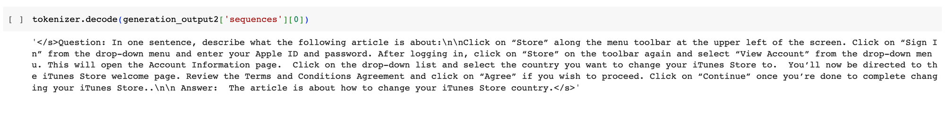

‣ Answer the following question given in this paragraph…

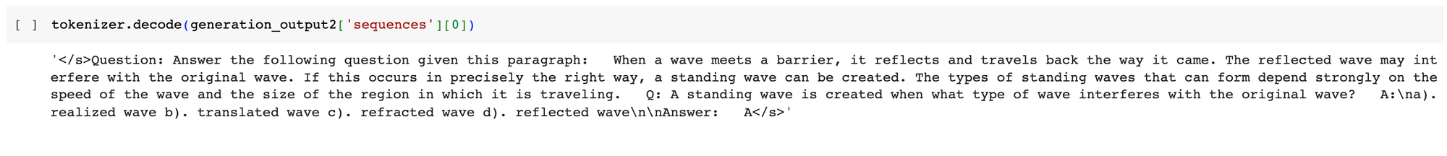

‣ What the following paragraph is about?…



‣ What the following paragraph is about?… (2)

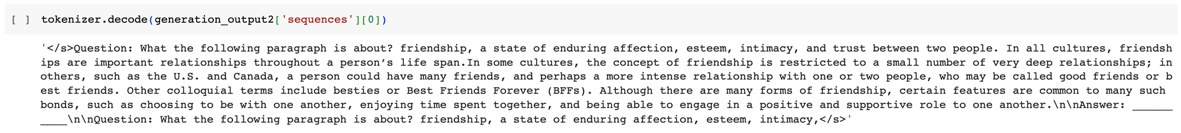

As evidenced by the examples, the model displays the ability to follow instructions and extract information from lengthy content. However, it falls short in terms of answering open-ended questions such as "Explain the raining process?” This is primarily attributed to the model's smaller size, which entails fewer parameters, approximately ranging from 30x to 70x less than state-of-the-art models.

## Conclusion

This lesson experimented with the three essential Reinforcement Learning with Human Feedback (RLHF) process stages. It starts by revisiting the Supervised Fine-Tuning (SFT) process, then proceeds with the training of a reward model, and finally concludes with the reinforcement learning phase. We explored and applied methods such as 4-bit quantization and LoRA to enhance the fine-tuning procedure while utilizing fewer resources. In the upcoming chapter, we will introduce the procedure of deploying models and utilizing them in a production environment.